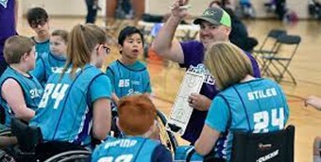
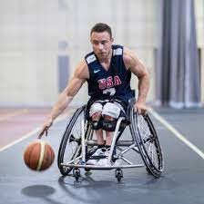

Eligibility
Youth Wheelchair Basketball Team(s) starting in Central PA

Friday evening practices beginning on October 7, 2022

Prep: Anyone 8-12 years of age with a physical disability Varsity: Anyone 13-18 years of age with a physical disability Must be able to self-propel a manual wheelchair independently
Sports Wheelchairs will be available if needed

Volunteers
Experienced volunteer coaches
All Volunteers have Child Line Clearances & Background checks

Sponsored by:

www.cilcp.org

Cost
No charge to practice.
During parent meeting we will discuss future program costs and sponsorship opportunities.

Date & Time
Mandatory Parent/Player meeting: Friday Sept. 30th 7pm in person at Spooky Nook

Location
Spooky Nook Sports Complex 75 Champ Blvd
Manheim, PA

Questions

Coach Keith McMinn

443-829-2460

kmcminn@pennstatehealth.psu.edu

The Center for Independent Living of Central Pennsylvania (CILCP) is committed to providing services, making referrals, and taking employment actions regardless of age, ancestry, color, disability, national origin, race, religious creed, sex, veteran status, or any other characteristic protected by applicable federal, state, or local laws and ordinances

