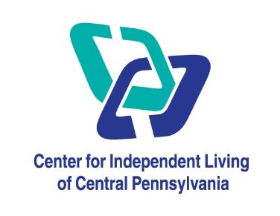

We offer appointment confirmation messages and reminders by text and/or email. If you wish to receive these text messages and/or emails we require your consent.

If you wish to receive these text messages and/or emails, please read the disclaimer below then complete and sign this form.

I consent to CILCP contacting me by text messages and/or email for the purposes of promotions and appointment reminders. I also understand that standard test messaging rates may apply.

I acknowledge that the responsibility of attending appointments and cancelling them still rest with me. I can opt out of the text and/or email function at any time.

I agree to advise CILCP of my mobile number and/or email changes if no longer in my possession.

Customer Name ____________________

Customer Phone Number __________________

Customer Signature ____________________

Date __________________

O By checking this box, I consent to receive SMS messages related to Appointments, Promotions, etc. from CILCP. You can reply “STOP” at any time to opt-out. Message and data rates may apply. Message frequency may vary. Text “HELP” for assistance. For more information, please visit our Privacy Policy and SMS Terms and Conditions.

**Email form to Office@cilcp.org